Write a program of crypt arithmetic using python code

Aim :To solve a Cryptarithmetic problem using Python .

Procedure:
Assign digits to letters.
Ensure each letter has a unique digit.
Check whether the arithmetic equation is satisfied.
Display the valid solution.

Python Code:
from itertools import permutations
letters = ('S','E','N','D','M','O','R','Y')
digits = (0,1,2,3,4,5,6,7,8,9)
for p in permutations(digits, 8):
S,E,N,D,M,O,R,Y = p
if S == 0 or M == 0:
continue
SEND = 1000*S + 100*E + 10*N + D
MORE = 1000*M + 100*O + 10*R + E
MONEY = 10000*M + 1000*O + 100*N + 10*E + Y
if SEND + MORE == MONEY:
print("Solution Found\n")
print("SEND =", SEND)
print("MORE =", MORE)
print("MONEY =", MONEY)
print("\nLetter Values")
print("S =", S)
print("E =", E)
print("N =", N)
print("D =", D)
print("M =", M)
print("O =", O)
print("R =", R)
print("Y =", Y)
break

Output:
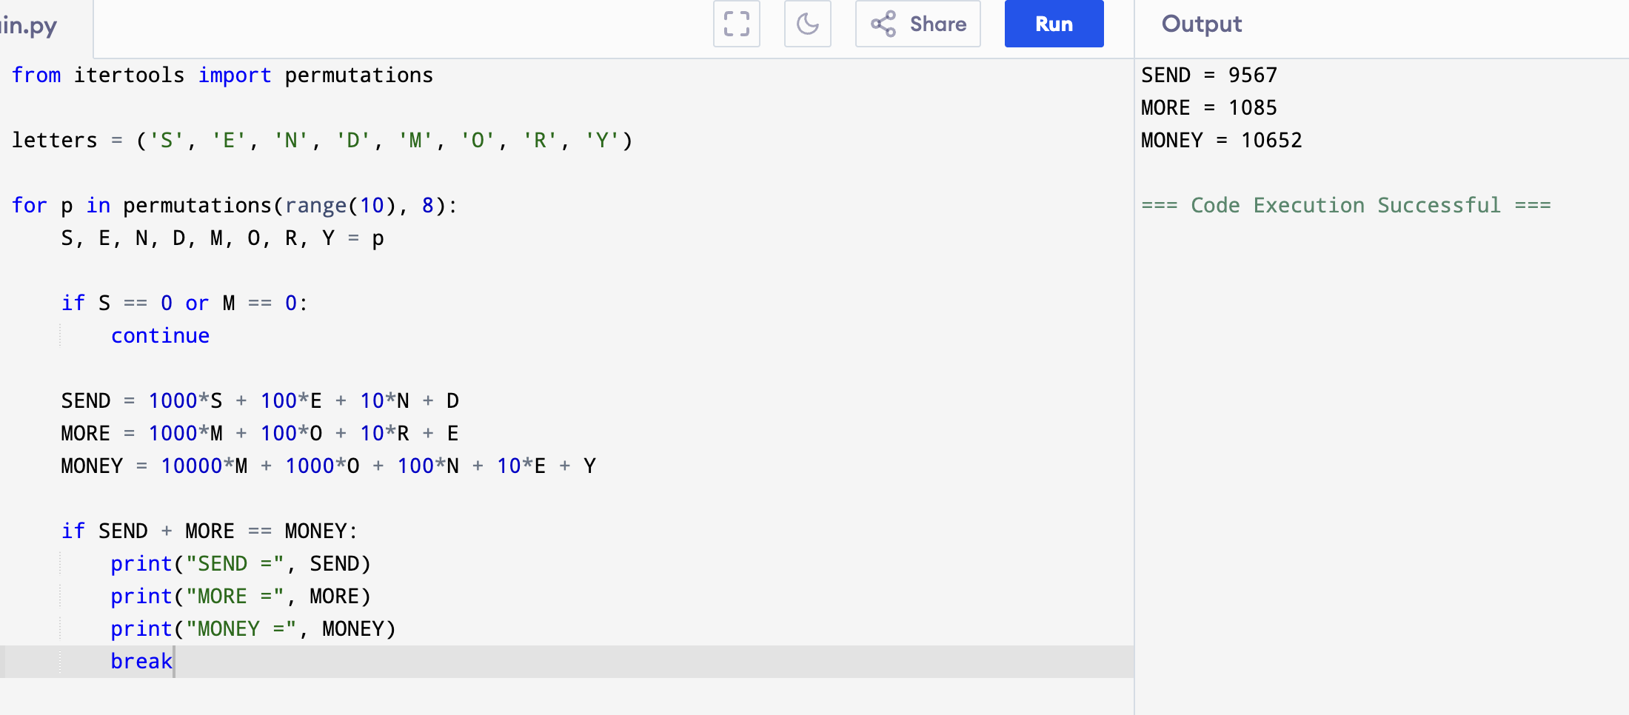
Flowchart:

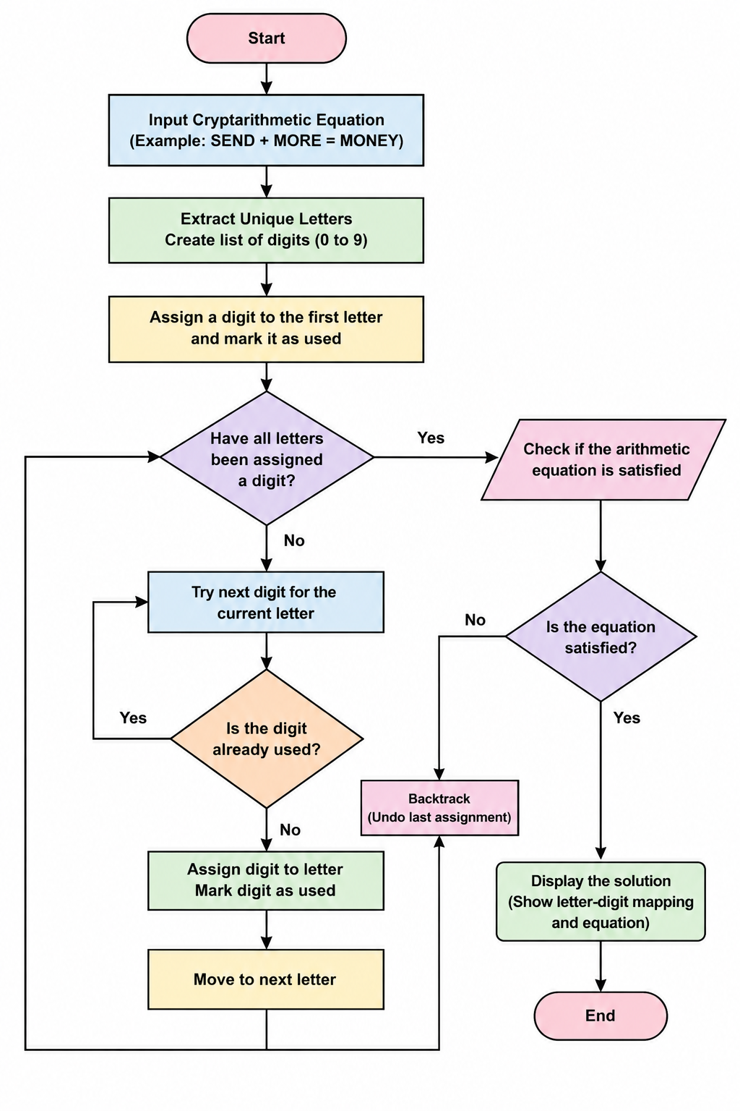

Result: Hence, crypt arithmetic problem has solved

